**Case Study 4**

**(Chapters 15 and 16)**

**This case study includes question from the chapters, monopoly and monopolistic competition.**

**Question 1: (50 points)**

Ross, Joey, Chandler, Monica, Rachel, and Phoebe made a documentary film sharing their experiences from the ten seasons of “Friends”. They are thinking of making the movie available for download on the internet, and they can act as a single-price monopolist if they choose to. Each time their movie is downloaded, their internet service provider charges them a fee of $4. They are arguing about which price to charge customers per download. The accompanying table shows the demand schedule for their film.

|  |  |  |  |  |  |  |
| --- | --- | --- | --- | --- | --- | --- |
| **Price of Downloads** | **Quantity of Downloads Demanded** | **Total Revenue** | **Marginal Revenue** | **Total Costs** | **Marginal Costs** | **Profit** |
| $10 | 0 | 0 | - | 0 | - | 0 |
| $8 | 1 | 8 | 8 | $4 | 4 | 4 |
| $6 | 3 | 18 | 5 | $12 | 3 | 6 |
| $4 | 6 | 24 | 2 | $24 | 4 | 0 |
| $2 | 10 | 20 | 1 | $40 | 4 | -20 |
| $0 | 15 | 0 | -4 | $60 | 4 | 0 |

1. Calculate the total revenue and the marginal revenue per download. Please extend the above table and report your answers in a table format.
2. Ross and Rachel are proud of the film and want as many people as possible to download it. Which price would they choose? How many downloads would be sold? (figure out from the complete table with TR and MR)

If they only value the total downloads, they should sell 15 copies for free.

1. Chandler wants as much revenue as possible. Which price would he choose? How many downloads would be sold at that price? (Again, choose from the complete table)

To maximize revenue, they should sell 6 copies for $4 each.

1. Monica wants to maximize profits. Which price would she choose? How many downloads would be sold? **(Hint: Figure out the total costs and then the marginal costs for each quantity of downloads, extend the above table with TC and MC columns. For profit-maximization, MR = MC. If you don’t get a perfect equality, go for that output for which MR> MC)**

To maximize profits, sell 3 copies for $6 each

1. Joey and Phoebe want to charge the efficient price. What price would they charge? How many downloads would be sold? **(Hint: efficiency is possible when price equals marginal cost)**

The most efficient price to charge is $4 to sell 6 copies.

**Question 2: (30 points)**

The following equations describes a monopolist’s (who sells soccer balls in Durham area) demand, marginal revenue, total cost, and marginal cost:

Demand: P = 10 – Q

Marginal Revenue: MR = 10 – 2Q

Total Cost: TC = 3 + Q + 0.5 $Q^{2}$

Marginal Cost = 1 + Q

Where Q is the quantity and P is the price measured in dollars

Find out the profit-maximizing output of soccer balls. At what price they are sold? What is the monopolist’s profit? **(Hint: to figure out the profit you need to calculate the ATC, divided both sides of the given TC equation by Q to find the equation for ATC. Then plug in the Q and P values you have calculated).**

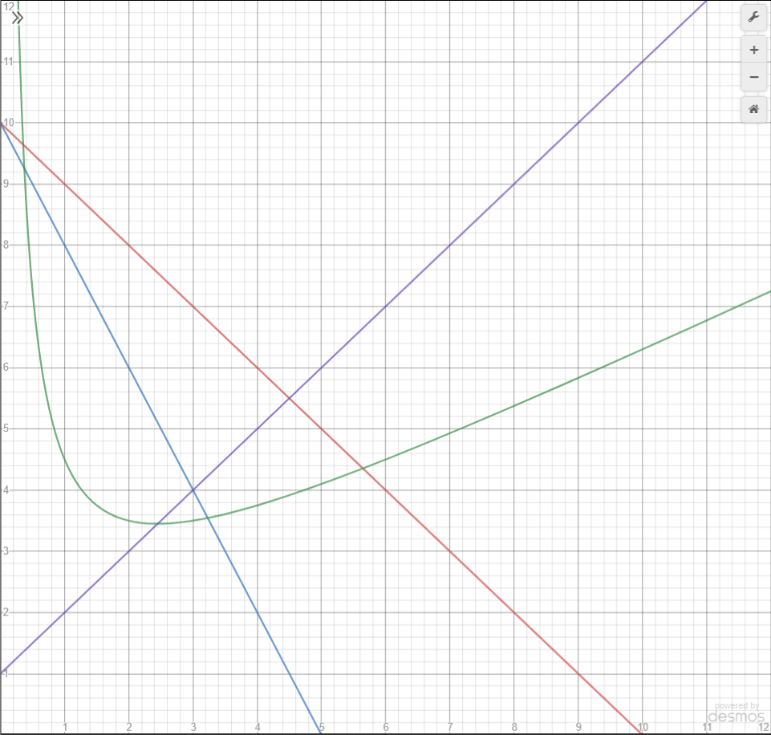

The profit maximizing output is 3 soccer balls at $7 each. The resulting profit is $9.

**Question 3: (10 points)**

Classify the following markets as perfectly competitive, monopoly, or monopolistic competition, and explain your answers.

1. Wooden no.2 pencils

perfectly competitive

1. Copper

perfectly competitive

1. Local electricity service

monopoly

1. Peanut butter

monopolistic competition

1. Lipstick

monopolistic competition

**Question 4: (10 points)**

For each of the following characteristics, say whether it describes a perfectly competitive, a monopolistically competitive firm, both, or neither.

1. Sells a product differentiated from its competitors

monopolistically competitive firm

1. Has marginal revenue less than price.

monopolistically competitive firm

1. Earns economic profit in the long run.

Neither

1. Equates marginal revenue and marginal cost to figure out the profit-maximizing output.

Both

1. Charges price above marginal costs.

Both